- Pick any one feature from a popular app you use daily (for example: Instagram signup, Flipkart add-to-cart, or Paytm recharge) and write 5 clear requirements for that feature.
Ans=> Instagram Sign Up
Requirements:
- The system allow a new user to create an account using an email address or mobile phone number.
- The system require the user to create a unique username and a password that meets minimum security requirements.
- The system verify the user's email address or mobile number by sending a verification code before the account login.
- The system display an error message if the entered email, phone number, or username is already with an existing account.
- The system create the user account and redirect the user to the profile setup or home screen after successful verification and registration.

- For the requirements you wrote in Task 1, create a table mapping each requirement to at least one test case that would verify it works as intended.<br><br><em><strong>Hint:</strong> Your table should have columns: Requirement ID, Requirement Description, Test Case ID, Test Case Description.</em>
Ans=>

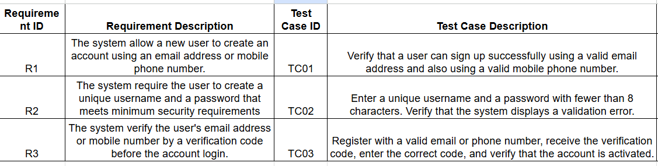

- Extend your table from Task 2 by adding a 'Defect ID' column. Imagine that during testing, you find 2 bugs related to your test cases. Link these defects to the relevant test cases in your table.<br><br><em><strong>Hint:</strong> Defects can be things like 'Signup button not enabled' or 'OTP not received'.</em>
Ans=>
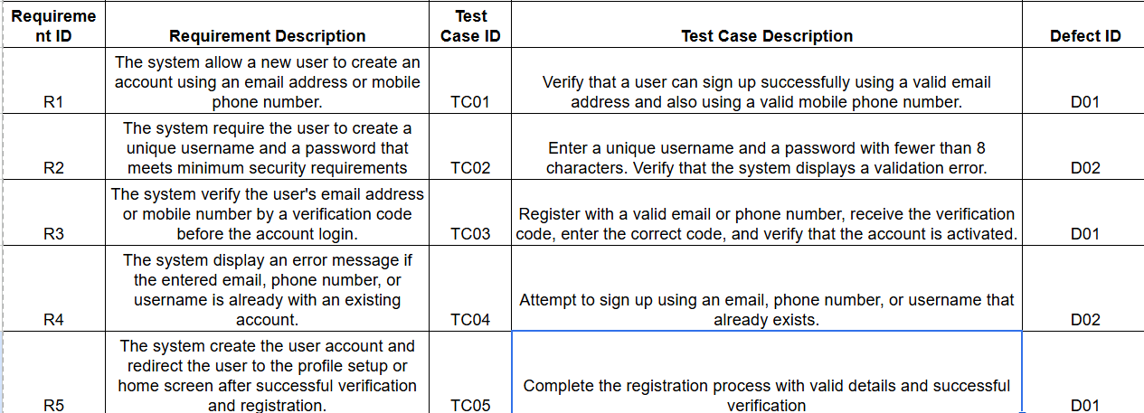

- Explain in 3-4 sentences the difference between forward traceability and backward traceability in the context of your table. Give one example of each using your requirements and test cases.
Ans=>
Forward Traceability – Mapping of Requirements to Test cases
For example, Requirement R3 is forward-traced to Test Case TC03, which tests whether the verification code is correctly received and validated.

Backward Traceability – Mapping of Test Cases to Requirement
For example, Test Case can be traced back to Requirement R4, which specifies that duplicate account details should trigger an error message.
5.
Create a bi-directional RTM (Requirements Traceability Matrix) for the login feature of a food delivery app like Zomato, showing how each requirement is linked to test cases and how test cases trace back to requirements.<br><br><em><strong>Constraint:</strong> Include at least 3 requirements and 5 test cases in your matrix.</em>

- Create a bi-directional RTM (Requirements Traceability Matrix) for the login feature of a food delivery app like Zomato, showing how each requirement is linked to test cases and how test cases trace back to requirements.<br><br><em><strong>Constraint:</strong> Include at least 3 requirements and 5 test cases in your matrix.</em>
Ans=>

